Circular-Region Generator

Definition
# Source: AI Source: Provided by: [Data Path: Persons Table -> ID Column: 1, Name_En Column: Motasem Essam] -> From: [ChatGPT] on [7/25/2026]
A Circular-Region Generator is a plane-region generator that uses a filled circular region (a disk) to produce three-dimensional solids through rotation, translation, or other spatial movements.
The most common application is rotating a circular region around an axis that passes through its center and lies in its plane. This generates a Right Circular Cylinder.
Other movements and axis positions can generate spheres, toroidal solids, and other solids of revolution.
Important distinction:
- A circular region (disk) is the filled area enclosed by a circle. Its movement can generate a solid.
- A circular boundary is only the circumference. Its movement generally generates a surface rather than a filled solid.

Geometric Representation
# Source: AI Source: Provided by: [Data Path: Persons Table -> ID Column: 1, Name_En Column: Motasem Essam] -> From: [ChatGPT] on [7/25/2026]
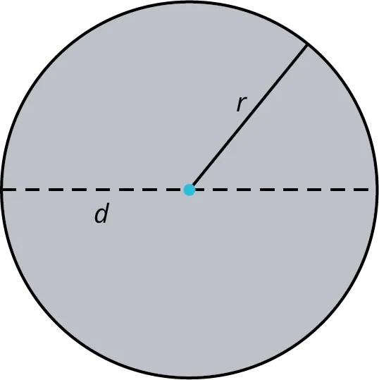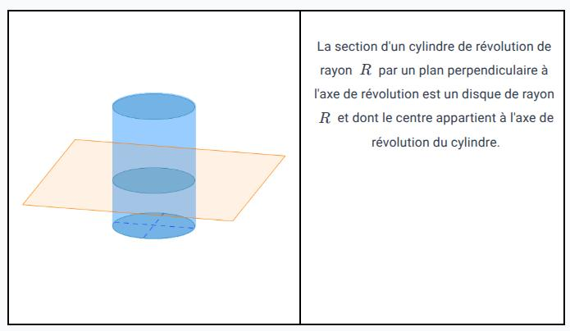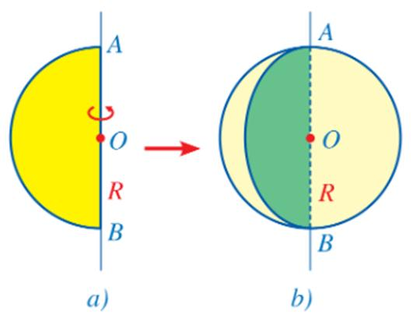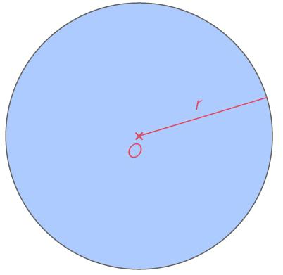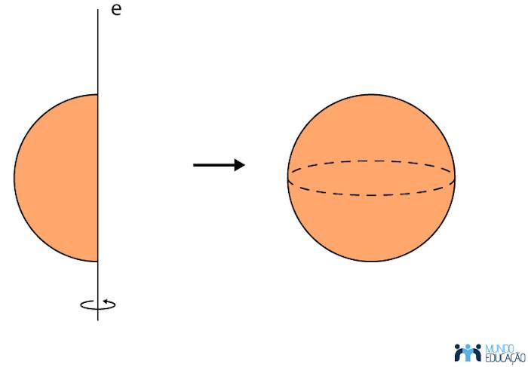

Geometric Structure
# Source: AI Source: Provided by: [Data Path: Persons Table -> ID Column: 1, Name_En Column: Motasem Essam] -> From: [ChatGPT] on [7/25/2026]
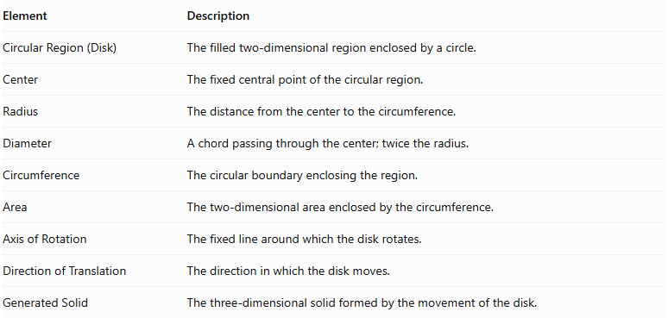
Element | Description
Circular Region (Disk) | The filled two-dimensional region enclosed by a circle.
Center | The fixed central point of the circular region.
Radius | The distance from the center to the circumference.
Diameter | A chord passing through the center; twice the radius.
Circumference | The circular boundary enclosing the region.
Area | The two-dimensional area enclosed by the circumference.
Axis of Rotation | The fixed line around which the disk rotates.
Direction of Translation | The direction in which the disk moves.
Generated Solid | The three-dimensional solid formed by the movement of the disk.

Types of Circular-Region Generators According to Movement

Rotational Circular-Region Generator
# Source: AI Source: Provided by: [Data Path: Persons Table -> ID Column: 1, Name_En Column: Motasem Essam] -> From: [ChatGPT] on [7/25/2026]
A circular region rotates around a fixed axis to generate a solid of revolution.
A. Rotation Around a Diameter
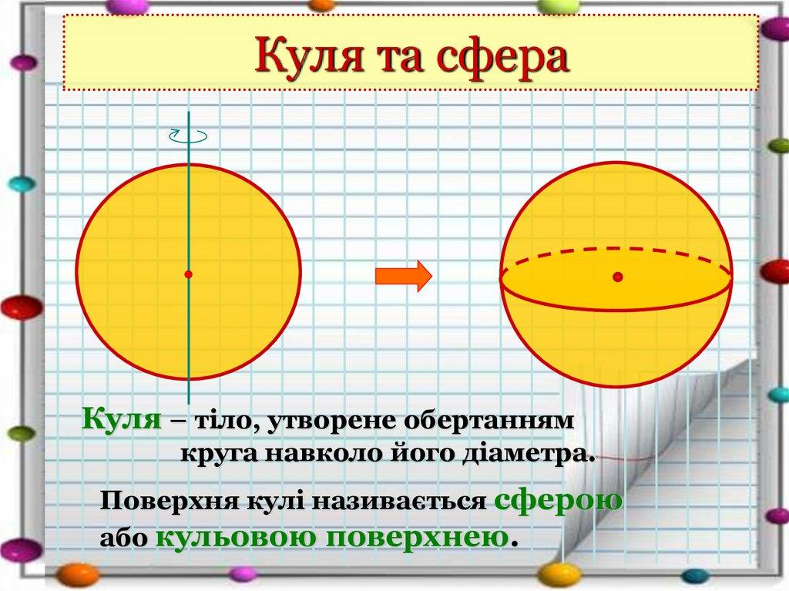
- Generates a Solid Sphere.
- The diameter acts as the axis of rotation.
- The radius of the disk becomes the radius of the sphere.
- Every point of the disk sweeps a circular path around the diameter.
B. Rotation Around an Axis in Its Plane Passing Through Its Center
This is equivalent to rotation around a diameter and therefore generates a solid sphere.
C. Rotation Around an External Axis in the Same Plane
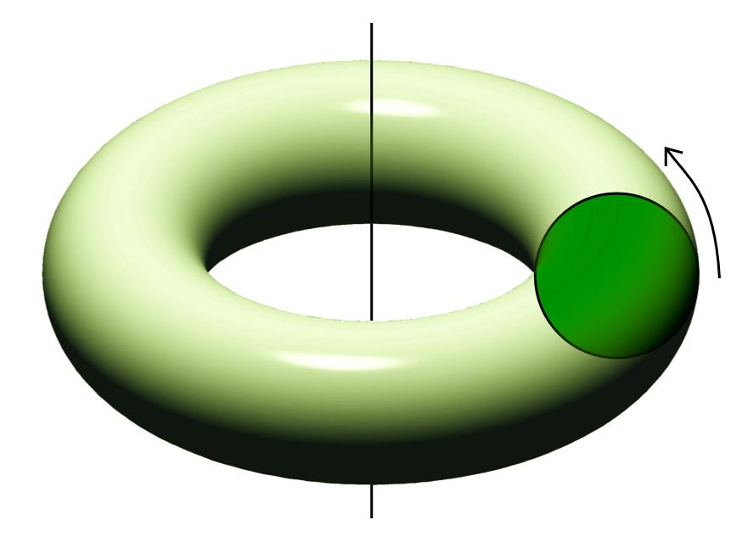
- Generates a toroidal solid when the axis does not intersect the disk.
- The distance from the axis to the disk's center determines the major radius.
- The disk radius determines the minor radius.
- The resulting solid is a ring-shaped toroidal solid when the distance to the center is greater than the disk radius.
D. Rotation Around an Axis Perpendicular to Its Plane and Passing Through Its Center
- The circular region remains unchanged as it rotates.
- It generates the same circular disk, not a new three-dimensional solid.

Translational Circular-Region Generator
# Source: AI Source: Provided by: [Data Path: Persons Table -> ID Column: 1, Name_En Column: Motasem Essam] -> From: [ChatGPT] on [7/25/2026]
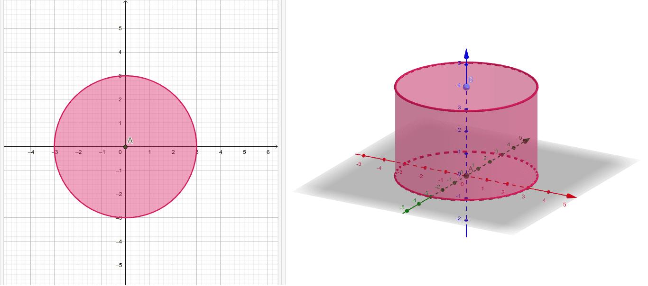
A circular region moves along a straight direction without changing its orientation.
A. Perpendicular Translation
- Generates a Right Circular Cylinder.
- The original disk forms one circular base.
- The translated disk forms the opposite circular base.
- The translation distance determines the cylinder's height.
B. Oblique Translation
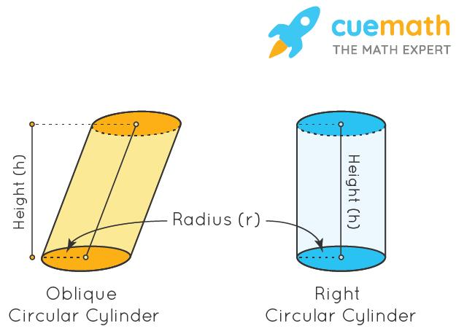
- Generates an Oblique Circular Cylinder.
- The two circular bases remain parallel and congruent.
- The translation direction is inclined relative to the plane of the disk.
- The perpendicular distance between the bases determines the cylinder's height.

Combined Rotational and Translational Circular-Region Generator
# Source: AI Source: Provided by: [Data Path: Persons Table -> ID Column: 1, Name_En Column: Motasem Essam] -> From: [ChatGPT] on [7/25/2026]
A circular region can undergo rotation and translation simultaneously.
The resulting solid depends on the movement path and the orientation of the circular region. Such motion can generate complex swept solids and should be classified according to its specific trajectory.

Mathematical Representation
# Source: AI Source: Provided by: [Data Path: Persons Table -> ID Column: 1, Name_En Column: Motasem Essam] -> From: [ChatGPT] on [7/25/2026]
Let a circular region have radius $r$.
Its fundamental measurements are:
Area:
$$A=πr^{2}$$
Diameter:
$$d=2r$$
Circumference:
$$C=2πr$$
Equation of the circular boundary:
$$x^{2}+y^{2}=r^{2}$$

Rotation Around a Diameter — Sphere
# Source: AI Source: Provided by: [Data Path: Persons Table -> ID Column: 1, Name_En Column: Motasem Essam] -> From: [ChatGPT] on [7/25/2026]
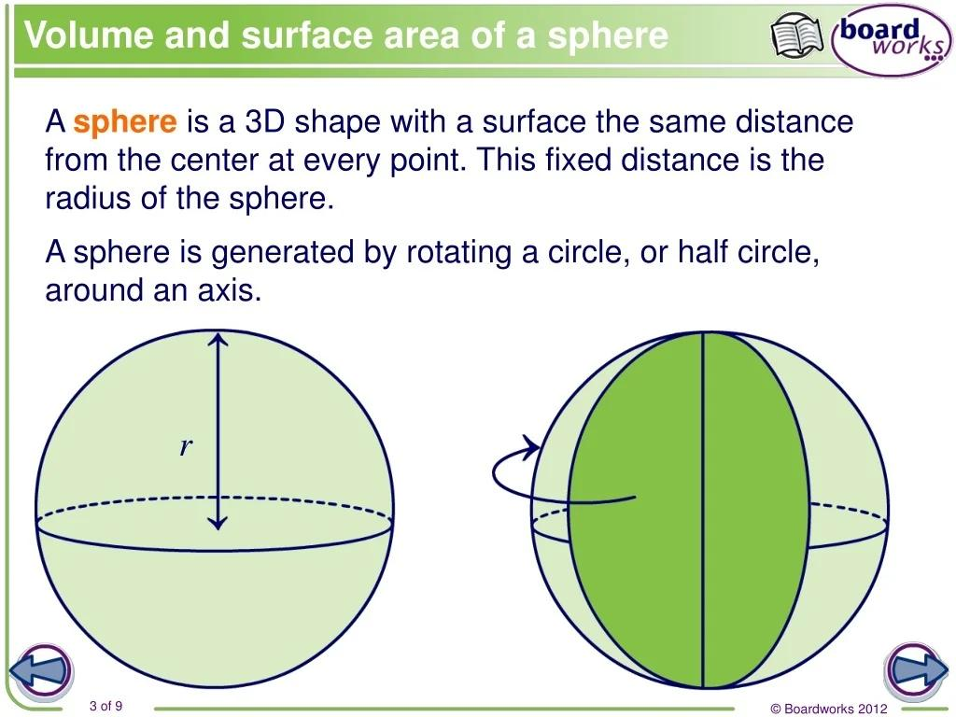
Rotating a circular disk around one of its diameters generates a sphere.
The resulting sphere has:
$$R=r$$
Surface area:
$$A_{s}=4πr^{2}$$
Volume:
$$V=\frac{4}{3}πr^{3}$$
The equation of the generated sphere is:
$$x^{2}+y^{2}+z^{2}=r^{2}$$

Rotation Around an External Coplanar Axis — Toroidal Solid
# Source: AI Source: Provided by: [Data Path: Persons Table -> ID Column: 1, Name_En Column: Motasem Essam] -> From: [ChatGPT] on [7/25/2026]
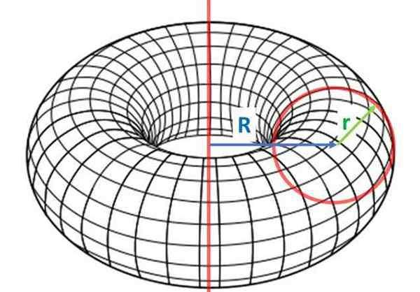
Suppose the axis is parallel to a diameter of the disk and lies outside it.
Let:
- $R$ = distance from the rotation axis to the disk center (major radius).
- $r$ = radius of the disk (minor radius).
The resulting toroidal solid is classified according to the relationship between $R$ and $r$.
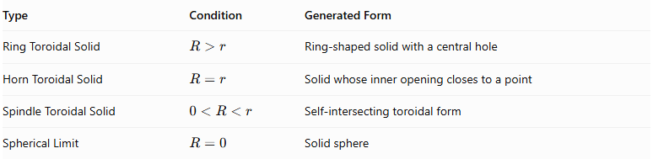
Type | Condition | Generated Form
Ring Toroidal Solid | $$R>r$$ | Ring-shaped solid with a central hole
Horn Toroidal Solid | $$R=r$$ | Solid whose inner opening closes to a point
Spindle Toroidal Solid | $$0<R<r$$ | Self-intersecting toroidal form
Spherical Limit | $$R=0$$ | Solid sphere
Volume of the ring toroidal solid:
$$V=2π^{2}{Rr}^{2}$$
The same volume expression applies to the spindle and horn parameterizations as a swept-volume integral, although the horn and spindle cases have special geometric characteristics.

Perpendicular Translation — Right Circular Cylinder
# Source: AI Source: Provided by: [Data Path: Persons Table -> ID Column: 1, Name_En Column: Motasem Essam] -> From: [ChatGPT] on [7/25/2026]
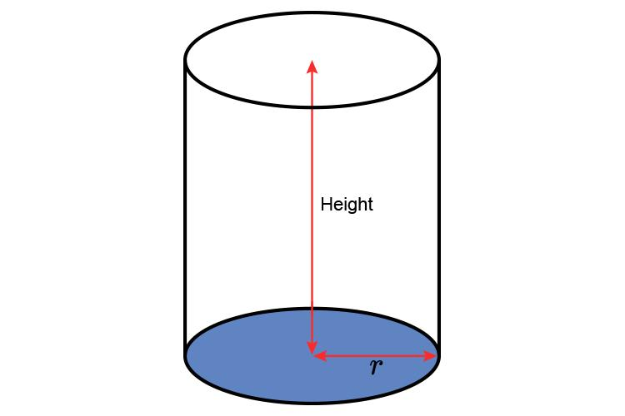
When a circular disk is translated perpendicularly to its plane through a distance $h$, it generates a right circular cylinder.
Volume:
$$V=πr^{2}h$$
Curved surface area:
$$A_{c}=2πrh$$
Total surface area:
$$A_{t}=2πr(r+h)$$

Oblique Translation — Oblique Circular Cylinder
# Source: AI Source: Provided by: [Data Path: Persons Table -> ID Column: 1, Name_En Column: Motasem Essam] -> From: [ChatGPT] on [7/25/2026]
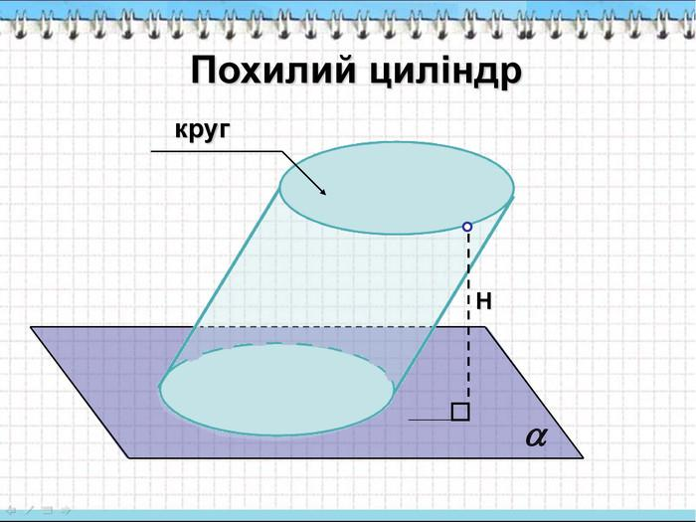
When a circular disk is translated obliquely to its plane, it generates an oblique circular cylinder.
Its volume is:
$$V=πr^{2}h$$
Where $h$ is the perpendicular distance between the two parallel circular bases, not the slanted translation distance.

Mathematical Properties
# Source: AI Source: Provided by: [Data Path: Persons Table -> ID Column: 1, Name_En Column: Motasem Essam] -> From: [ChatGPT] on [7/25/2026]
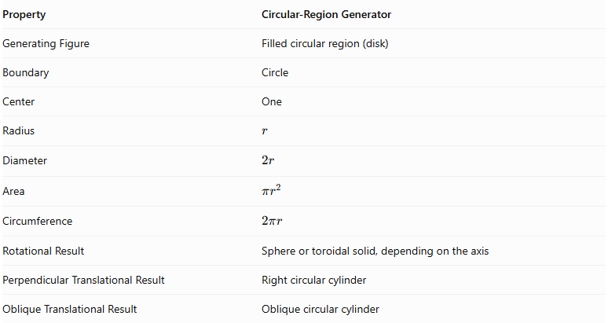
Property | Circular-Region Generator
Generating Figure | Filled circular region (disk)
Boundary | Circle
Center | One
Radius | $$r$$
Diameter | $$2r$$
Area | $$πr^{2}$$
Circumference | $$2πr$$
Rotational Result | Sphere or toroidal solid, depending on the axis
Perpendicular Translational Result | Right circular cylinder
Oblique Translational Result | Oblique circular cylinder

Generated Surfaces and Solids

Sphere
# Source: AI Source: Provided by: [Data Path: Persons Table -> ID Column: 1, Name_En Column: Motasem Essam] -> From: [ChatGPT] on [7/25/2026]
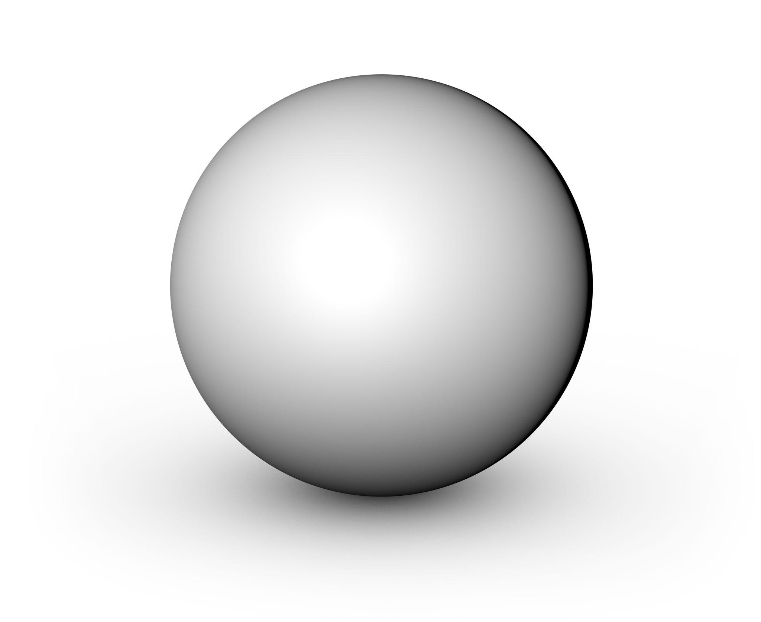
Generated by rotating a circular region around a diameter.

Toroidal Solid
# Source: AI Source: Provided by: [Data Path: Persons Table -> ID Column: 1, Name_En Column: Motasem Essam] -> From: [ChatGPT] on [7/25/2026]
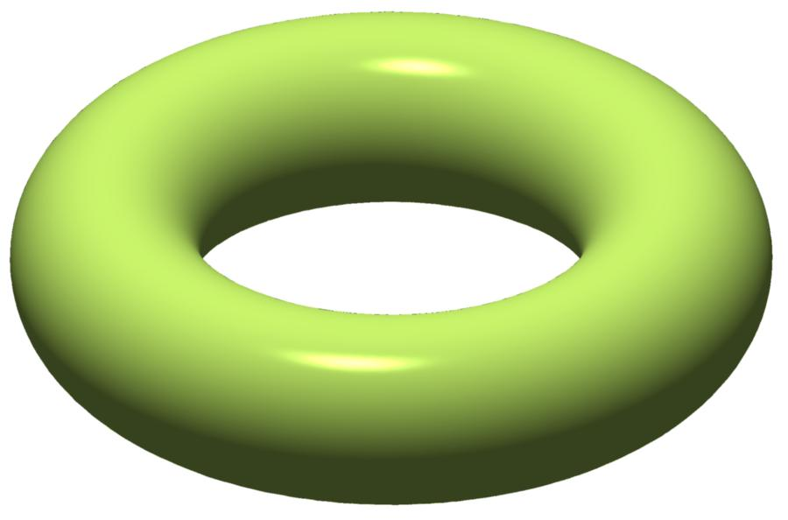
Generated by rotating a circular region around an external coplanar axis.

Right Circular Cylinder
# Source: AI Source: Provided by: [Data Path: Persons Table -> ID Column: 1, Name_En Column: Motasem Essam] -> From: [ChatGPT] on [7/25/2026]
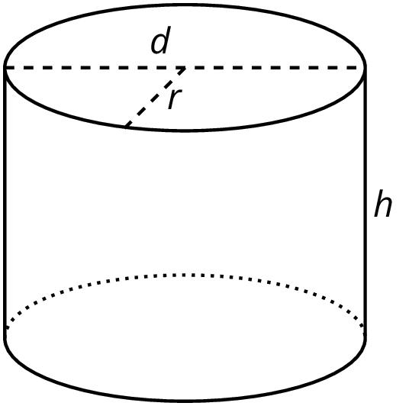
Generated by translating a circular region perpendicularly to its plane.

Oblique Circular Cylinder
# Source: AI Source: Provided by: [Data Path: Persons Table -> ID Column: 1, Name_En Column: Motasem Essam] -> From: [ChatGPT] on [7/25/2026]
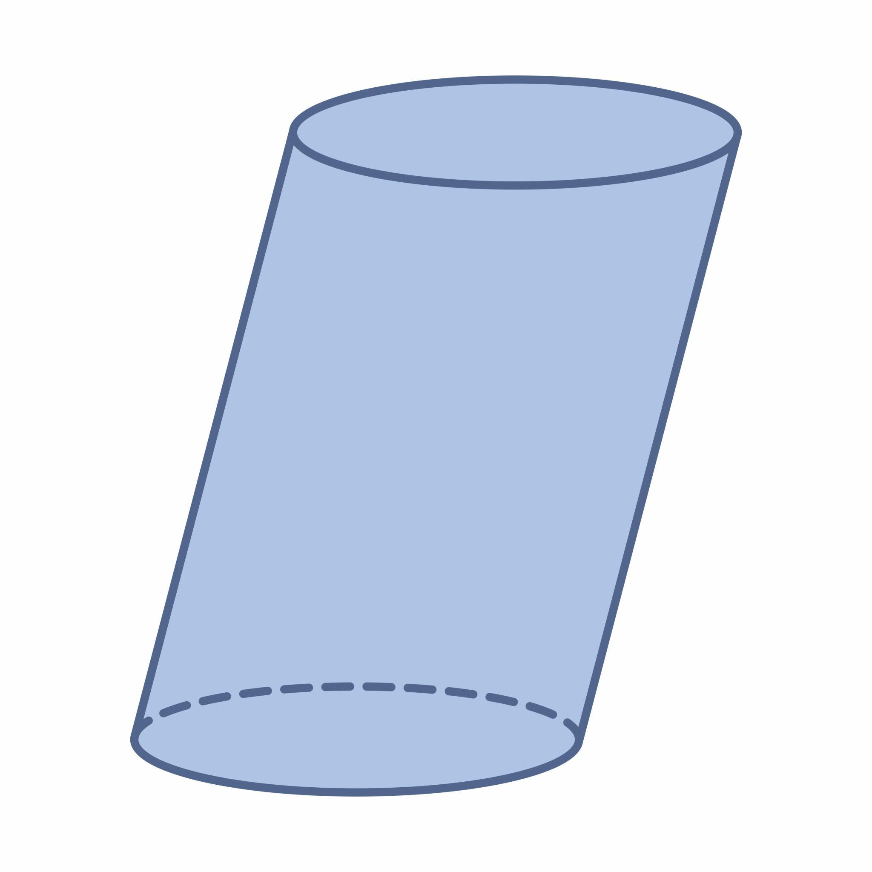
Generated by translating a circular region in an oblique direction relative to its plane.

Applications
# Source: AI Source: Provided by: [Data Path: Persons Table -> ID Column: 1, Name_En Column: Motasem Essam] -> From: [ChatGPT] on [7/25/2026]
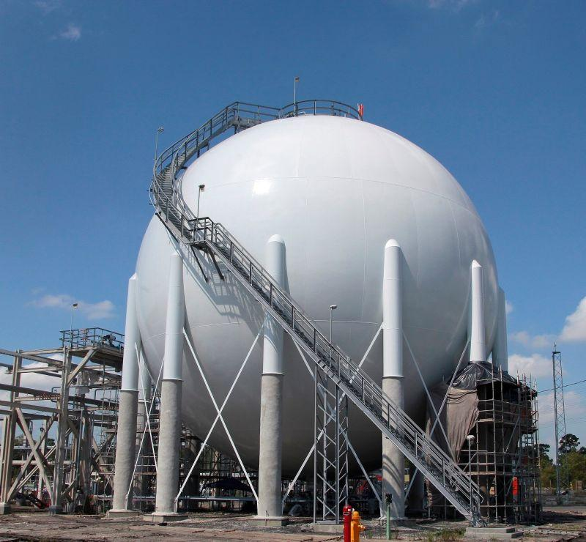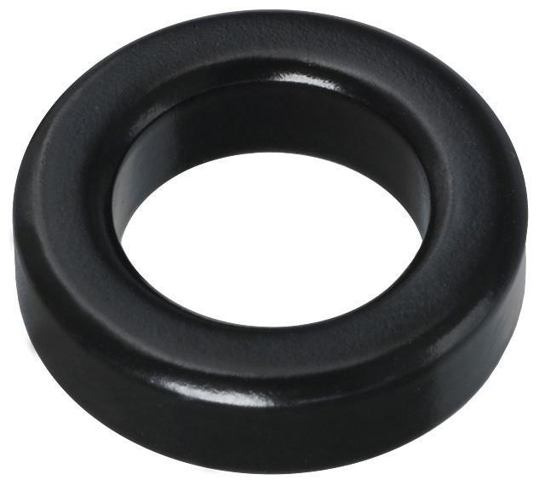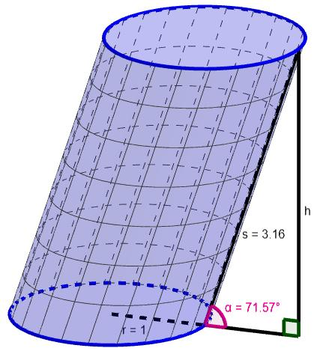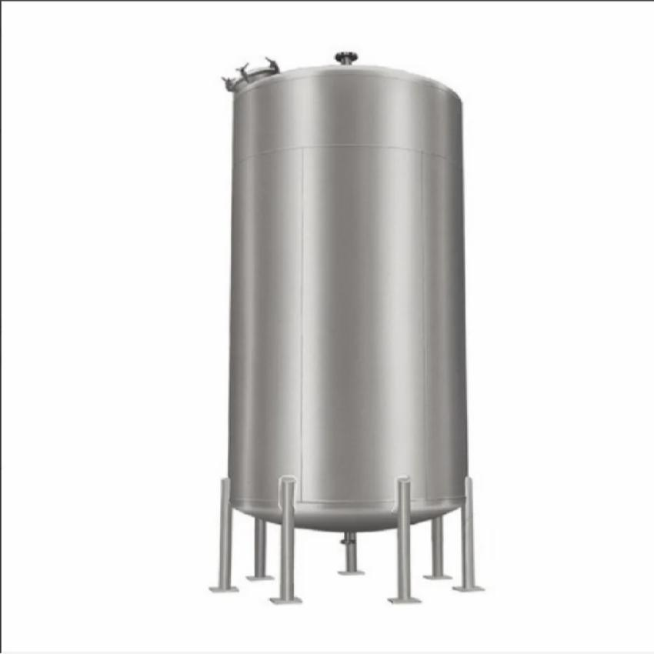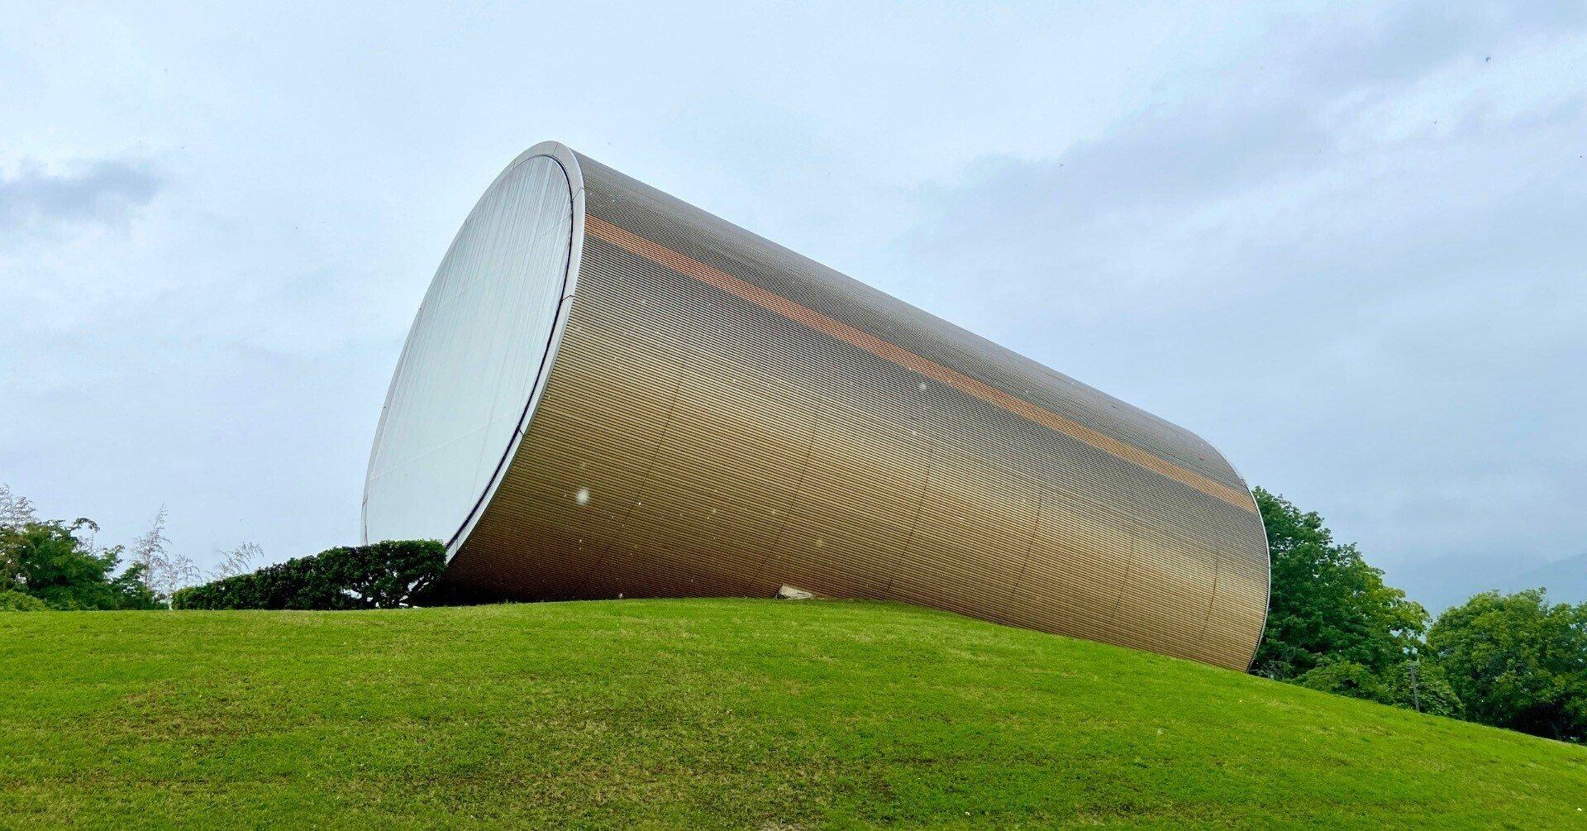
- Spherical Containers: Storage tanks and pressure vessels.
- Toroidal Components: Toroidal cores, mechanical components, and ring-shaped structures.
- Cylindrical Containers: Water tanks, cans, and storage vessels.
- Mechanical Manufacturing: Cylindrical and rotational components.
- Architecture: Circular columns and cylindrical structural elements.

Comparison with Other Plane-Region Generators
# Source: AI Source: Provided by: [Data Path: Persons Table -> ID Column: 1, Name_En Column: Motasem Essam] -> From: [ChatGPT] on [7/25/2026]
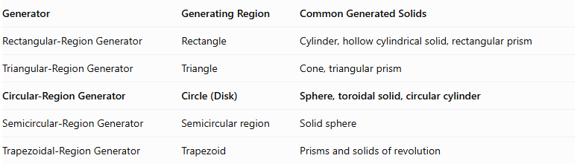
Generator | Generating Region | Common Generated Solids
Rectangular-Region Generator | Rectangle | Cylinder, hollow cylindrical solid, rectangular prism
Triangular-Region Generator | Triangle | Cone, triangular prism
Circular-Region Generator | Circle (Disk) | Sphere, toroidal solid, circular cylinder
Semicircular-Region Generator | Semicircular region | Solid sphere
Trapezoidal-Region Generator | Trapezoid | Prisms and solids of revolution

Main Classification
# Source: AI Source: Provided by: [Data Path: Persons Table -> ID Column: 1, Name_En Column: Motasem Essam] -> From: [ChatGPT] on [7/25/2026]
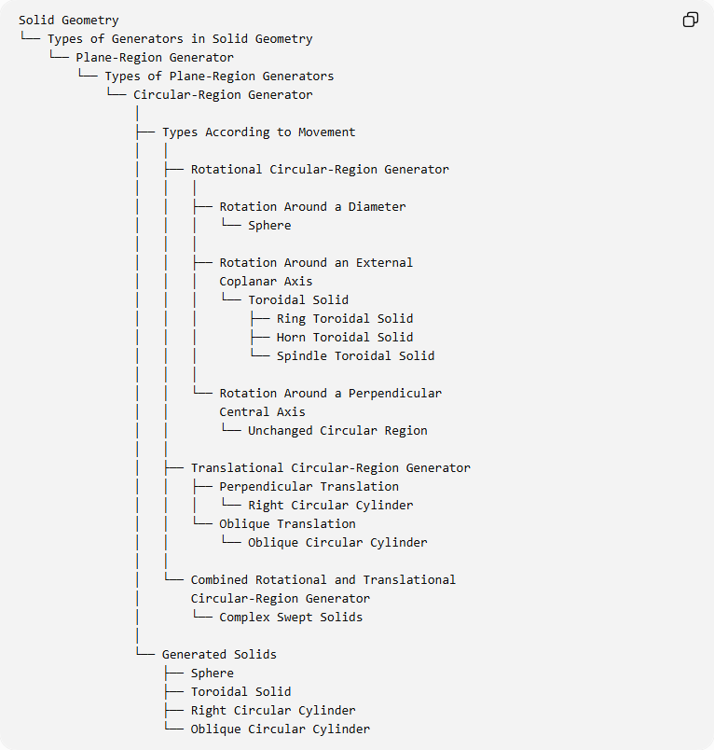
Solid Geometry
└── Types of Generators in Solid Geometry
└── Plane-Region Generator
└── Types of Plane-Region Generators
└── Circular-Region Generator
│
├── Types According to Movement
│ │
│ ├── Rotational Circular-Region Generator
│ │ │
│ │ ├── Rotation Around a Diameter
│ │ │ └── Sphere
│ │ │
│ │ ├── Rotation Around an External
│ │ │ Coplanar Axis
│ │ │ └── Toroidal Solid
│ │ │ ├── Ring Toroidal Solid
│ │ │ ├── Horn Toroidal Solid
│ │ │ └── Spindle Toroidal Solid
│ │ │
│ │ └── Rotation Around a Perpendicular
│ │ Central Axis
│ │ └── Unchanged Circular Region
│ │
│ ├── Translational Circular-Region Generator
│ │ ├── Perpendicular Translation
│ │ │ └── Right Circular Cylinder
│ │ └── Oblique Translation
│ │ └── Oblique Circular Cylinder
│ │
│ └── Combined Rotational and Translational
│ Circular-Region Generator
│ └── Complex Swept Solids
│
└── Generated Solids
├── Sphere
├── Toroidal Solid
├── Right Circular Cylinder
└── Oblique Circular Cylinder

Key Points
# Source: AI Source: Provided by: [Data Path: Persons Table -> ID Column: 1, Name_En Column: Motasem Essam] -> From: [ChatGPT] on [7/25/2026]
- A circular-region generator uses a filled circular disk as its generating figure.
- Rotating the disk around a diameter generates a sphere.
- Rotating it around an external coplanar axis generates a toroidal solid.
- Translating it perpendicularly to its plane generates a right circular cylinder.
- Oblique translation generates an oblique circular cylinder.
- The axis position and movement determine the resulting geometric form.
- Rotating a circular disk around its perpendicular central axis does not generate a new three-dimensional solid.

Conclusion
# Source: AI Source: Provided by: [Data Path: Persons Table -> ID Column: 1, Name_En Column: Motasem Essam] -> From: [ChatGPT] on [7/25/2026]
The Circular-Region Generator is an important plane-region generator in solid geometry. Its circular generating region can produce spherical and toroidal solids through rotation and cylindrical solids through translation.

